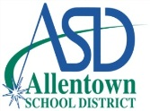
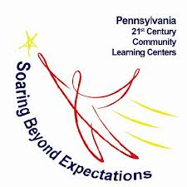
21st Century Community Learning Centers
After School Program
2019-2020

Student Consent Form and Release of Information

Dear Parent/Guardian,
Thank you for your interest in the 21st Century program! If you would like to enroll your student, please complete the information below and return it to South Mountain Middle School. We will contact you with your child’s start date. Placement is dependent on available spots so please be aware that your child may be placed on a waiting list. If you have any questions, please contact April McGovern, Project Coordinator, at 484-765-4094 or mcgoverna@allentownsd.org.

STUDENT PERSONAL INFORMATION

Student Name: | Student ID#:
School: Grade: | Date of Birth:
Allergies:
Additional Information:

Parent/Guardian Name:
Phone Number: |  | Email Address:
STUDENT RELEASE INFORMATION

Please list all individuals (ages 14 and older) who have permission to pick up your child from the 21st Century After School Program. Please include first/last names and phone numbers. If a change needs to be made or an individual needs to be added, please notify the Project Coordinator.

Name: Phone #:
Name: |  | Phone #:
Name: |  | Phone #:

CONSENT/RELEASE OF INFORMATION

I hereby give permission for my child to be interviewed by a representative of Educational Enterprises, LLC. (2331 Pennsylvania Avenue, Philadelphia, PA 19130) to evaluate the quality of the 21st Century Community Learning Centers Program. □ YES □ NO

Parent/Guardian Name (Printed):
Parent/Guardian Signature:

